THIS WEEK at GLENN
January 3, 2018

Dear Glenn Families:
Happy, Happy New Year! Welcome back to a new and exciting year at Glenn.
Announcements and Reminders:
1. Look for 2018-19 Application information in your child’s backpack this week. Placement is guaranteed if your child’s application is received no later than February 1, 2018. Lunch Bunch registration is on going until capacity is reached. Registration forms are also being sent home today.
2. In case of Inclement Weather, Glenn School follows the DeKalb County School System. In the instance that DeKalb County Schools are open for a partial day (either a delayed opening or early closing), the Glenn School will be closed. Please listen to you local stations for school closings.
3. We are planning some new and FUN activities this winter and spring: special art projects for all classes, Goodies with Guys, Goodies with Gals, and a memorable night with parents. Stay tuned…
4. Open House for Prospective and Current Parents is January 22nd at 6:30pm. All classrooms will be open, and teachers will be available to answer questions.
5. Correction to the last This Week at Glenn: Cookies with Santa made approximately $1500.00 and not the originally reported $2500.00. Please excuse my typo!
6. The Glenn School for Young Children children’s concert series continues Sunday, January 21 at 4 p.m. with a unique opportunity to see world renowned organist Timothy Albrecht and experience the organ and piano up close with a 30 minute "wiggles are welcome" concert. The performance is open to the public and will be held in the sanctuary at Glenn Memorial Methodist Church, 1660 N. Decatur Rd. next to the Emory University campus.
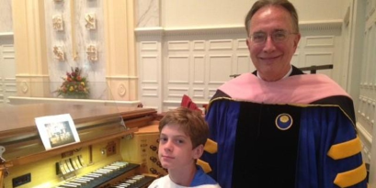
“Did you know an organist uses both hands and both feet to play the organ--at the same time? Did you know that an organ has different voices? It can sound like a flute, trumpet, or chimes in addition to its organ sound,” asks Reverend Susan Pinson, Glenn Church Minister for Children and Older Adults. Attendees will experience the answers to both.
Doors open 15 minutes prior to the event time. Admission is $10 per person or $30 per family (a deal for a family of 3 or more). Purchase Tickets Here
The performance is a benefit for the Glenn School.
Cherry

