**THIS WEEK at GLENN**

February 9, 2018

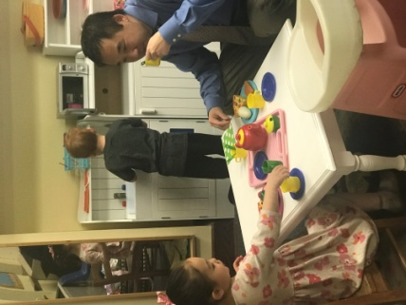Dear Glenn Families:

Whew…What a very BUSY and EXCITING week we have had at Glenn.

* **Goodies with Guys**---The children were thrilled to show off their favorite, special “guy” and spend time in their classroom showing him around. Some classes were brimming over with excitement, while others were quiet and filled with soft conversation. I hope everyone enjoyed this event.
* 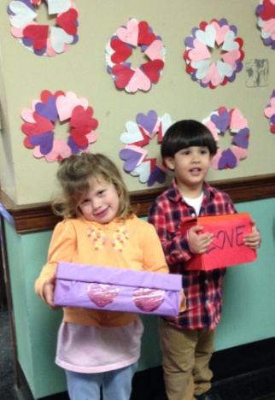The children have been working on their art projects for the art auction. After some discussion, we thought the auction would be a great addition to Family Day. Plan to attend on April 28th, rain or shine. The auction will be one of many fun activities. More information will follow at a later date.

Teacher Appreciation Week---First a word from Meredith Swartz and Monica Dierkes: We can't thank you enough for your incredible generosity and support of our teachers and staff this week.  We were able to provide two amazing meals and a special treat for everyone in the form of a gift card at the school level, not to mention the sweet recognitions that took place in each classroom and office.  We would like to extend a special thanks to the Teacher & Staff Appreciation Committee and the Room Parents for helping to coordinate this week's events and contributing lots of delicious food.

Best, Meredith Swartz & Monica Dierkes, Teacher & Staff Appreciation Co-Chairs

The teachers and staff have become so very spoiled this week. Everyday has been something special, one surprise after another. It is just like Christmas in February. The luncheon on Wednesday was outstanding. We are fortunate to have such wonderful parent volunteers. Thank you to Meredith, Monica and the Teacher Appreciation Committee for a week filled with special treats, thoughtful gifts, cards, flowers, and a delicious lunch! You are the best.

* Glenn School Application Process---Reminder: If you applied on or before February 1, 2018, you are automatically registered for the 2018-2019 school year. Families will be notified of their acceptance no later than March 31, 2018.
* Homeless at Heart--- Thank you for your donations to Homeless at Heart. The decorated boxes with the toiletries and goodies were picked up Monday and delivered to a nearby shelter. Glenn School is very generous as we have donated canned goods at Thanksgiving, mittens, etc. at Christmas and now much needed supplies to a shelter for homeless men. Thank you for your generosity.
* It is extremely important that you keep your child home if he or she shows any signs of illness. We have children out daily due to strep, viruses, flu, and other common illnesses. Our classrooms and offices are cleaned daily; however the best way to prevent the spread of germs is to remain home.

Glenn Memorial United Methodist Children’s Ministry Activities

**Ash Wednesday Services.** **Feb 14, 6:15 p.m. and 6:30 p.m.** Join us as we welcome the season of Lent. At 6:15 p.m. in the Little Chapel, we’ll have a short, 15-minute service for children and families that introduces the season of Lenten traditions in a child-friendly way. At 6:30 p.m. in the Sanctuary, we’ll have a meditative service with the reading of Scripture, prayers, hymns, and the ritual of the imposition of ashes. Childcare available.

**KIDS & FAMILY NIGHT @ Snack in a Backpack.**  **Thur, Feb 22, 4pm.**  Join us for an earlier time perfect for families after school and before dinner to volunteer to help with assembly-line packing of food bags for local school children in need of weekend supplementary food.

**Stewards of Children – prevention of child sexual abuse training.** **Mon, Feb 26, 9:30am-12pm.**

 Room 401. Darkness to Light’s Stewards of Children child sexual abuse prevention training is used across the country by parents, school systems, law enforcement agencies, churches, and childcare networks to help reduce the risk of child abuse. In partnership with the [Georgia Center for Child Advocacy](https://glennumc.us6.list-manage.com/track/click?u=7e16c729d6b9acb36547c564b&id=64bf884452&e=1ba6abf54d) and thanks to generous Glenn donors, Glenn Church is able to offer this community training for free, including childcare.  Parking available at [Emory’s Fishburne Visitor deck](https://glennumc.us6.list-manage.com/track/click?u=7e16c729d6b9acb36547c564b&id=ab06a36139&e=1ba6abf54d) ($8).   CEU’s are available for counselors, social workers, nurses, educators and lawyers.  RSVP with Rev. Susan Pinson [spinson@glennumc.org](mailto:spinson@glennumc.org) [404-634-3936](tel:(404)%20634-3936) by February 21st.

**REGISTER NOW: Family Retreat** **April 20-22, 2018** Lake Junaluska, NC. (registration & deposit due by Feb 15) Be a part of the Glenn Church tradition of the “Junaluska Jaunt” to the beautiful mountains of North Carolina. We have reserved Lagaolinda Inn (just like “the good ole’ days” for some of our 2nd generation Glenn families!). Recommended donation is $100 per adult and $50 per child (max $275 per family) – includes two nights, all meals on Saturday, and breakfast on Sunday. Scholarship subsidies available – just ask. (And let us know if you have other accommodations, but want to join us for activities/meals, etc. More accommodations available at [Lake Junaluska.](https://glennumc.us6.list-manage.com/track/click?u=7e16c729d6b9acb36547c564b&id=35b85cbb75&e=1ba6abf54d)) The weekend will be low-key, relaxing fun. We are within steps of the beautiful mountain lake, 2.5 mile walking path, a brand-new playground, tennis and shuffleboard courts, and more! Bring your bikes, balls, kites, Frisbees, musical instruments and board games! Enjoy family time, get to know other Glenn families, and explore the quaint mountain town of Waynesville.    
  
**“For the Bible Tells Me So” Exploring Children’s Bible Stories for Grown-ups Stumped by Kids’ Questions!**   **Wednesdays, 6:30pm (resumes Feb 21st)**Room 401.  Optional: Bring any children's Bible - we will be using [The Jesus Storybook Bible](https://glennumc.us6.list-manage.com/track/click?u=7e16c729d6b9acb36547c564b&id=0b18dc41a9&e=1ba6abf54d) if you'd like to have your own copy!

Calendar:

February

16, 19, 20 School Closed

22 Hibernation Day/ Pajama Day

23 Spirit Day

March

1 Tuition Due

8 Glenn Sale Preview Night

9,10 Glenn Sale

See You in the Carpool Lane,

Cherry